**Function declaration and function expression**

1. They are different in syntax.
2. Function declaration can be called from anywhere (**after or before** the function statement) but function expression can be called only **after** the function statement.

**Example 1:** Function calls can be only written after function expression.

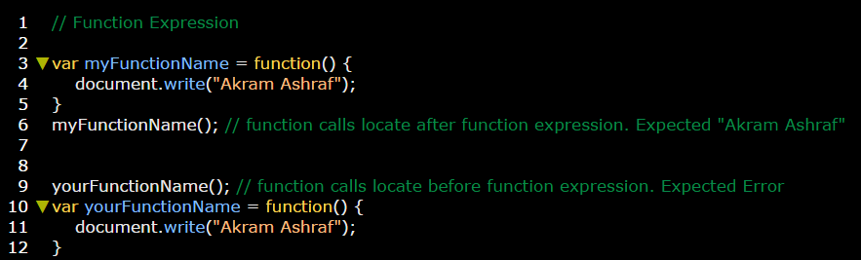

**Example 2:** Function calls can be both written after & before function declaration.

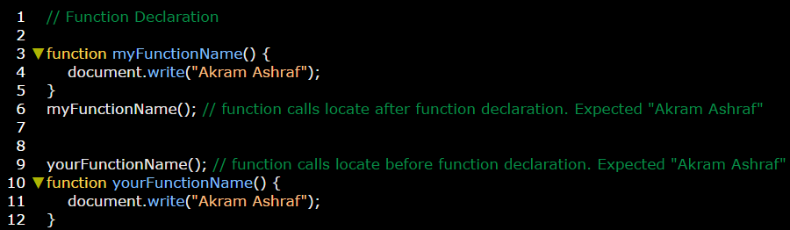

**The reason of working function call before and after declaration function and work only after expression function is:**

Function declarations conceded a hoisted function while function expression considered not hoisted function.

**Hoisted** means: that the function can raise itself to be over the function call

**Non hoisted** means: that the function can’t raise itself to be over the function call.

